BANKING MANAGEMENT SYSTEM

DATABASE PROJECT REPORT

SUBMITTED BY: ALI ASJAD(SP22-BCS-055)

MUNEEB IQBAL(SP22-BCS-030)

DDL COMMAND

**We have created Tables User, Account, Transaction, Loan and Bank Statement using DDL Command, also included Alter Command.**

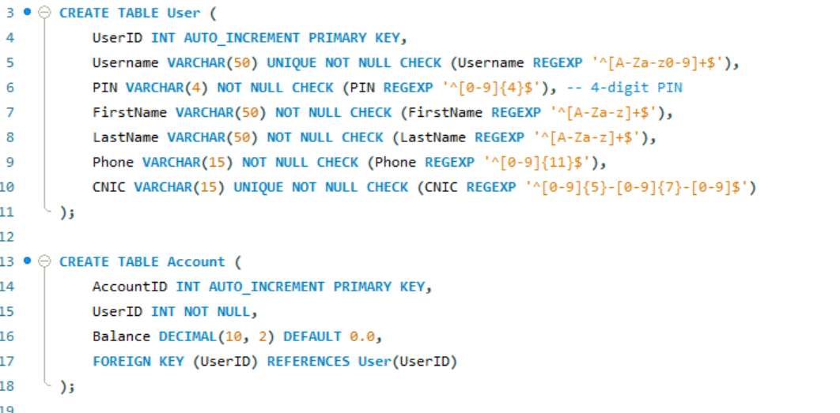

Here,it is verified that tables have been created.

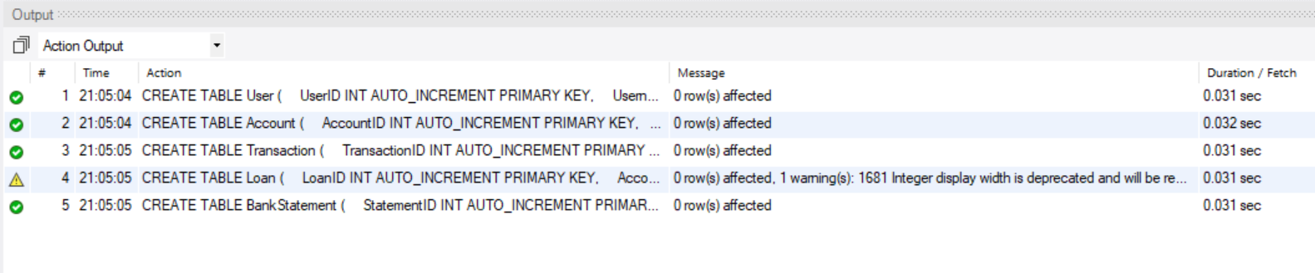

**DML COMMANDS**

**Here, we have inserted data in rows of Every Tables.**

**

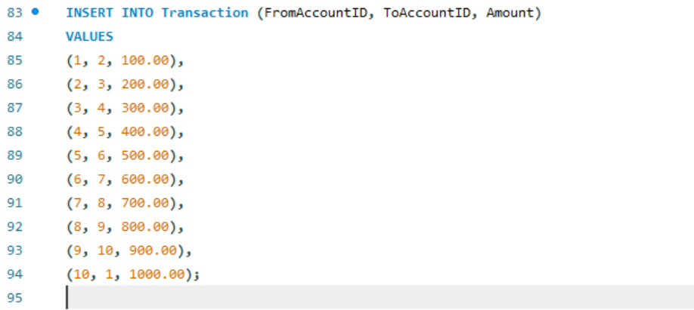

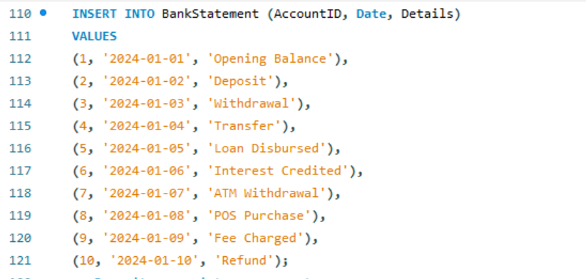

HERE,IT IS VERIFIED THAT DATA HAS BEEN INSERTED.

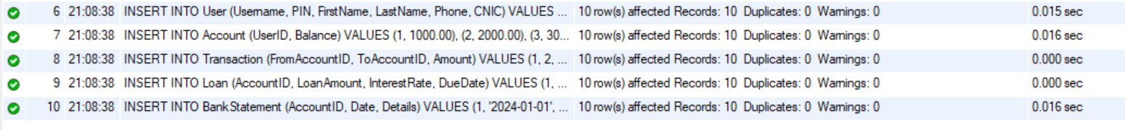

PROOF OF DDL AND DML COMMAND

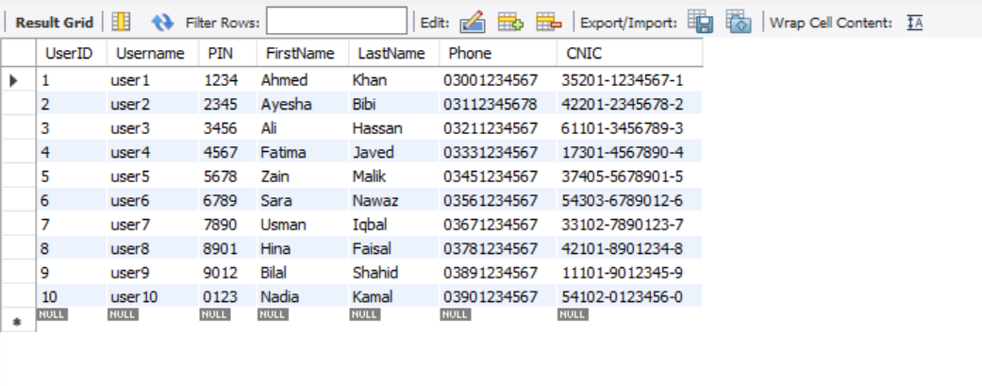

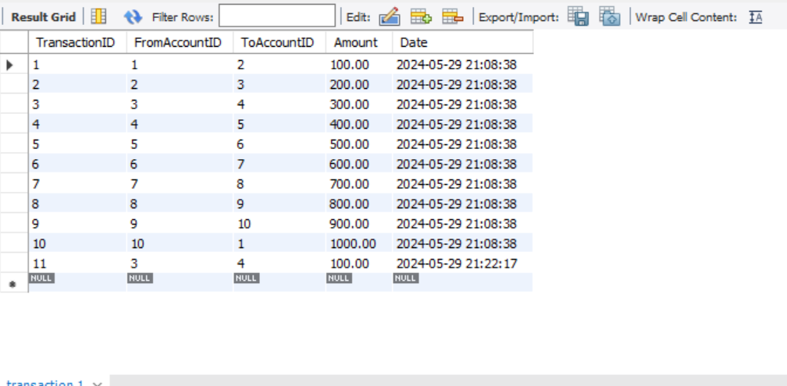

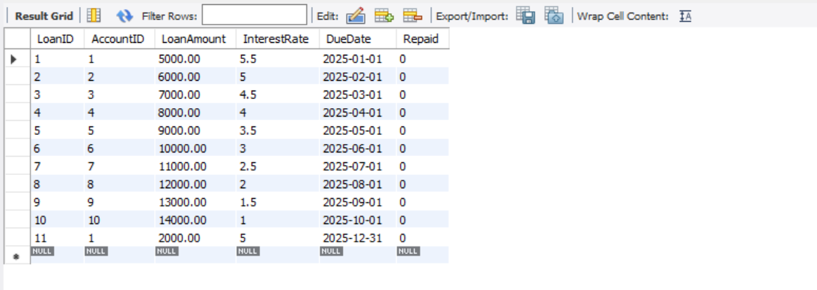

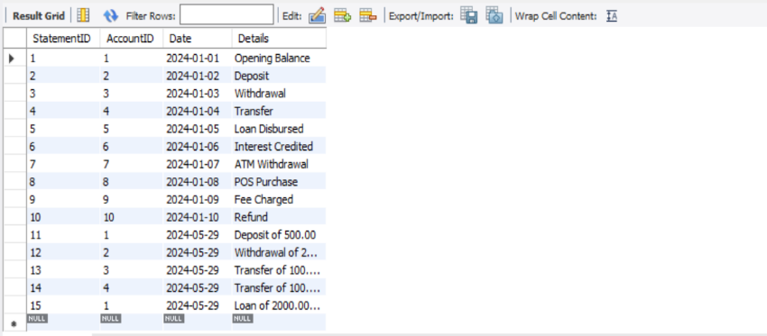

WORKING OF BANKING MANAGEMENT SYSTEM USING DML COMMANDS

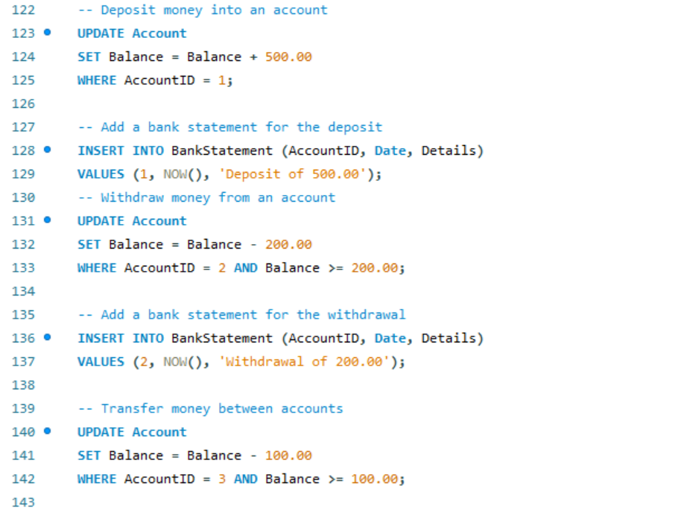

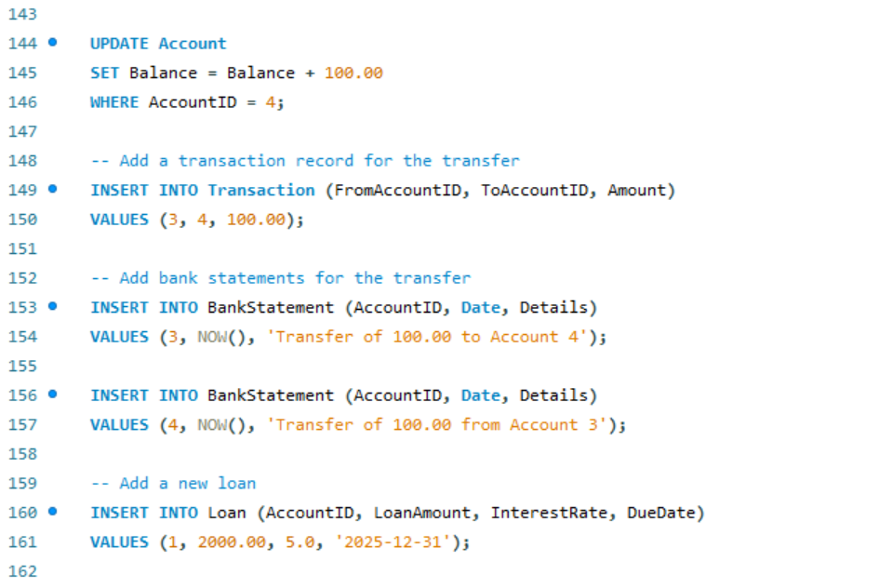

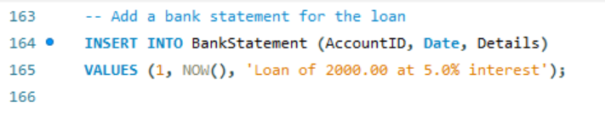

Here, it is verified that it is working properly

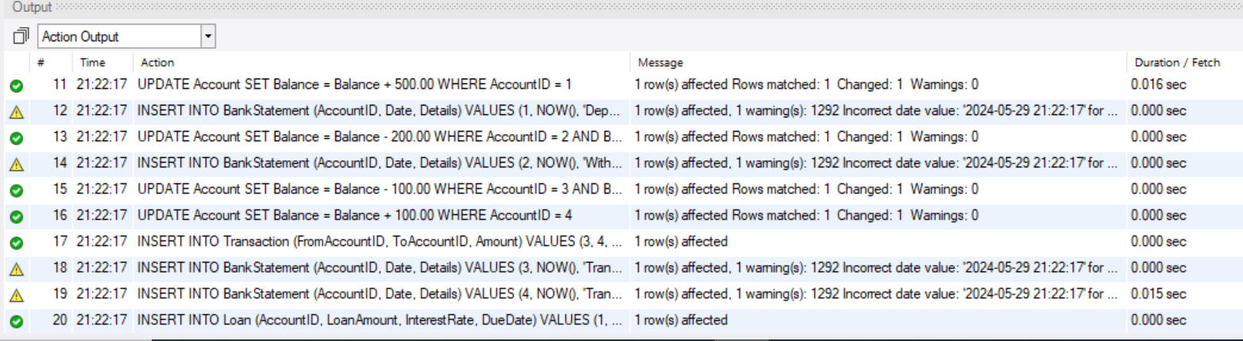

JOINS

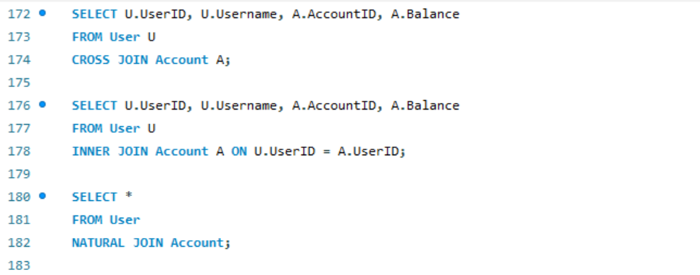

OUTPUT OF JOINS

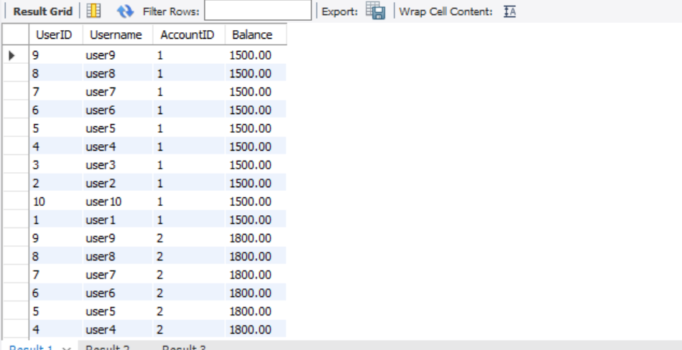

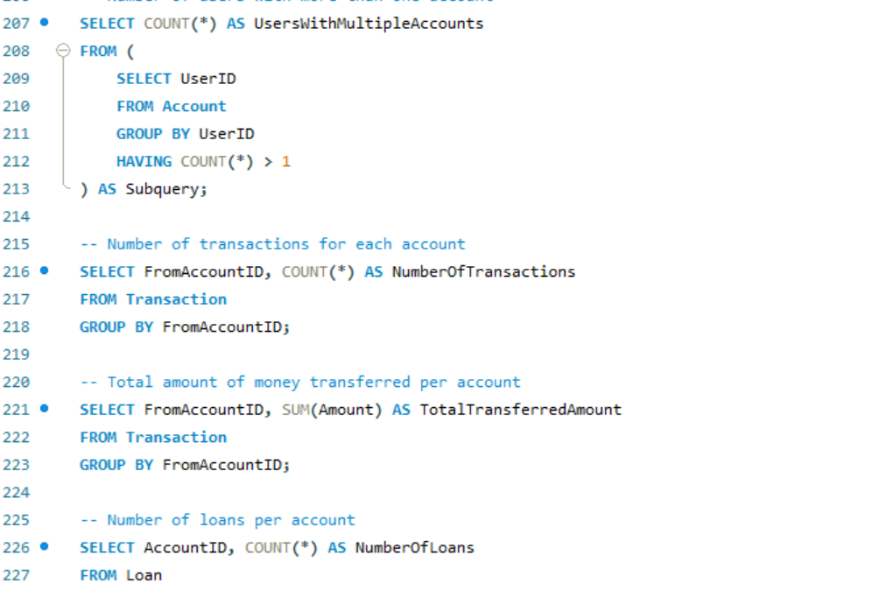

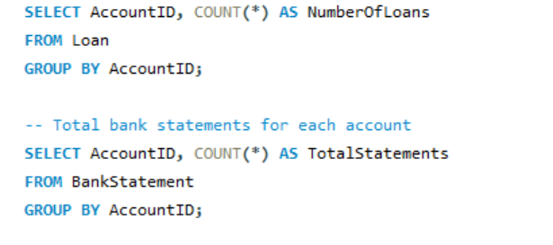

OUTPUT OF GROUP FUNCS



